A Brief History of the Village Hall, Trefriw.

The early history of Trefriw Village Hall is closely linked with the development of the Nonconformist denomination in the village; it was built in 1861, originally as a Nonconformist place of worship. Its history since 1881 has been as a Public Hall.
The location of the Hall, off the main street and hidden behind another property, largely reflects the sensitivities of a former period. Although the Independents were by this time accepted as mainstream and no longer faced persecution, this had not always been the case, and some still felt that keeping to a site out of direct view of the established church of St. Mary’s was appropriate.

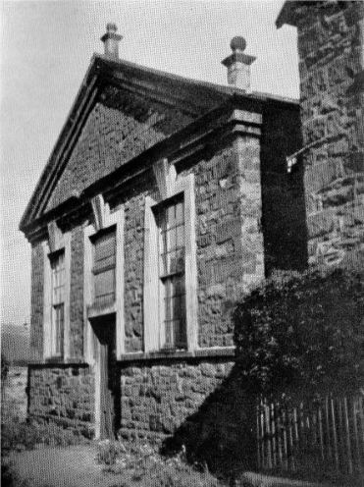
The Village Hall, c.1930

Designed not to look overly like a place of worship, it was built in a restrained classical Georgian style with pedimented ends and a shallow roof. It will be seen that it also had chimneys (added later). To all intents and purposes it resembled a grand house, though without being too imposing or ostentatious.
Its use as a church, however, was short-lived, for it proved too small for the growing number of worshippers, and in 1881 its congregation moved to the newly constructed Ebenezer chapel on Crafnant Hill.
After this date the building became a public venue for meetings, concerts and shows, etc., and was also used for fundraising events by many of the groups and societies in the village. A map of 1890 shows it marked as “Trefriw Hall”. In the early 20th century it was usually referred to as the ‘Public Hall’.

A brief history of the Nonconformist religious movement in Trefriw
Religious context - Those who did not wish to follow the denomination of the Anglican Church of England (later Wales), i.e. Nonconformists, were mostly represented in Trefriw by the Independents (later called Congregationalists) and the Calvanistic Methodists (becoming the Presbyterian Church of Wales). The latter operated within the Established Church for many years before formally splitting in 1811.
There were various periods of religious revival between the 18th and early 20th centuries, but a measure of the greatest religious revival in Wales can be measured by the fact that between 1800 and 1850 one chapel a fortnight, on average, was erected in Wales.

The Independent cause in Trefriw started in the 1740s after the visit of a travelling preacher to the remote Ardda farm of Cwm Brwynog. This visit coincided with the festival of the ‘Gŵylmabsant’ (Patron Saint festival), one of several fair days in Trefriw which, owing to the combination of betting, feasting and alcohol consumption, had built-up a reputation for rowdiness. Consequently many drunken young men went after the preacher with sticks. Some 8 years later, the Rev. Peter Williams visited, and was treated similarly. He nevertheless returned at intervals afterwards.
These Nonconformist Independents, also called ‘dissenters’, were terribly persecuted at the time. Visiting preachers were physically attacked, and their followers risked the same treatment, even having their houses burned down. Despite the Established church being present in Trefriw and Llanrhychwyn for many centuries (St. Mary’s was founded by Llywelyn Fawr c.1130, and that at Llanrhychwyn in the 6th century), these new Nonconformists were seen as a threat, who were out to overthrow and topple the established church. They also provided an easy excuse for violence, for which Fair Days were renowned. The Nonconformists were, of course, out to do no such thing; they simply wanted to worship in their own way, free from the rules and increasingly formal rituals of the Established church. Nevertheless, they largely had to meet in secret.
In 1780, some 32 years after his first visit, Peter Williams preached at Cwmanog, the home of John and Jane Thomas, where they also held a Sunday school.
The congregation grew and there were ultimately too many for the limited space at Cwmanog, so some started meeting at nearby Plas Engan. (The family at Cwmanog were more Independent/Congregational in outlook, whilst that at Plas Engan was more Methodist in outlook, and in time these two groups were to develop into followers of the Congregational and the Calvinistic Methodists, but lack of space was essentially the original cause of this ‘split’.)
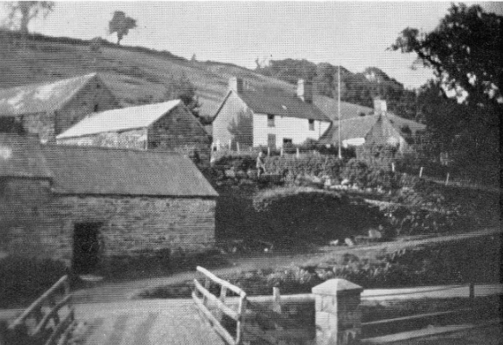
Cwmanog, first home of the Independents prior to their move to the village hall site.

A frequent visiting preacher was Daniel Evans of Bangor, and through his recommendation Mr. Azariah Shadrach (originally of Machynlleth) came to preach in the Trefriw area. He was ordained in Llanrwst in 1802, and came to live in Trefriw. A man called David Owen had at the time a workshop (on part of the site of the current Village Hall), and Shadrack rented this at a rate of 2 guineas a year to preach there, and to hold a Sunday school.
The Independents from Cwmanog thus moved to David Owen’s workshop in the centre of the village, this being the first Nonconformist dedicated place of worship in Trefriw.
This first place of worship was small; it measured 15’ x 10’, and was just 7’ high. As a result of Mr. Shadrach’s popularity the place soon became too crowded, and it was enlarged 5’ in width by pulling down a partition between it and the wooden building adjacent to it. Of its height, it was reported that "a short man could reach the eaves on the outside”. Moreover, it had “just one window, which was not 3’ in each direction, and there was no way of opening it to let a little air in. Three-quarters of the floor was earth, and hummocks and hollows. The short people would try and sit on the hummocks, and the tall ones would stand in the hollows. The other part of the floor was paved ....”
Despite the obvious unsuitability of the place, the congregation was obliged to stay here for 32 years through their inability to get land to build something better, despite numerous attempts and requests to Lord Willoughby De Eresby of Gwydir, the landowner, via his steward.
The Methodists, meanwhile, had moved to meet at Yr Hafod, a larger property, and the home of John and Margaret Jones. John died in 1879, his memorial describing him as “a faithful deacon with the MC (Methodists) for 31 years”. This likewise became too small, and at about the same time as the Independents were moving to the future Village Hall site, the Methodists were pursuing their own dedicated place of worship. Peniel Chapel (by Peniel footbridge, and now demolished) was built in 1860 at a cost of £2,000, replacing a previous smaller chapel on the same site (which was there from at least 1828). This in turn was to close in 1910, on completion of the new Peniel Chapel (in the village centre next to St. Mary’s) which was built large enough to easily hold the growing congregation.
There were also outlying chapels - variously attached to either the Independents or the Methodists - at Ardda (built 1845), Crafnant (built 1876, services being previously held at Cynllwyd), Rhibo, Brwynog and Siloh (both near Llyn Cowlyd), and Llanrhychwyn. Visiting preachers would often preach in up to three venues on a Sunday, travelling between them on foot.
To return to the Village Hall site, in 1832 Lord Willoughby happened to come to Trefriw to see some tenants, and Mr. Hugh Hughes of Tynewydd (who was sympathetic to the Independent cause, though not a member) met with him by the old workshop chapel, and persuaded him to go in and look at the place. Lord Willoughby agreed that it was unsuitable, and needed extending, and it was decided immediately to demolish it and build a new chapel.
His overseer/steward, however, was less accommodating, and permission to make the building any higher was refused. Moreover, the rules stated that any Nonconformist place of worship had to be plain, should not draw attention to itself, and could not be taller than the houses around, so as to avoid any offence. Thus it could not be raised or widened, only lengthened. Consequently the only thing to be done was to sink the floor down by a couple of feet into the earth, put a wooden floor on it, and a step going down to it. Thus the building was made 12 yards by 6 inside, with places to sit throughout, but it was far from comfortable.
Somewhat improved, members now started taking communion here; previously they had gone to Llanrwst for this. (Links with the independent movement in Llanrwst has existed from the beginning, and were not severed until 1850.)
The growing number of converts to the Nonconformist cause was not unique to Trefriw. The religious census of 1851 revealed that total Nonconformist attendance was now very close to that of Anglicans (i.e. the Established Church), and increasingly any feelings of having to be a covert or inferior denomination faded.
In 1860, through the assistance of Lewis Pugh, Esq. of Dolgellau, they eventually succeeded in purchasing extra land from the Gwydir Estate to build a new chapel, namely the building we see today. Some members wanted to move to a new, more prominent location, but many were still attached to the old site because of its origins. On completion, worship started here on March 31st, 1861. It was reported that “It is a strong and beautiful building, measuring 42’ by 30’. It cost £560, but all the debt has been paid.” Within, it had an upper balcony.
As a result of its success, this large 1861 building had within 20 years to again be replaced as a place of worship; its successor was the Ebenezer chapel, designed by a Liverpool architect, and built by William Evans, of Betws-y-coed, at a cost of £1646.15s 6d.
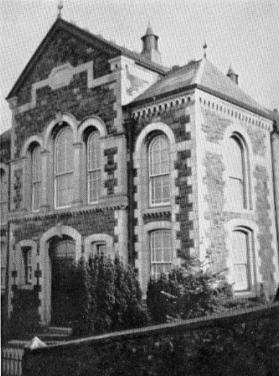
Ebenezer Chapel, successor to the ‘village hall’

The Public Hall
From 1881, the former Chapel became Trefriw’s Public Hall. The 1860s and 1870s had seen a considerable number of new properties being built in Trefriw, and with this came a considerable growth in the resident population. Hence it was necessary for both Independents and Methodists to build new places of worship at this time; and this was timely in that the former Independent chapel was available to be purchased for use as a Public Hall.
This was then followed by a 20 year golden period in Trefriw’s history (from c1890 to c1910) when the seasonal population of the village was swelled considerably by tourists, and additionally the steamer trade was at its most popular, bringing many hundreds of visitors daily to the village.
At this time the village also had an Improvement Committee; there can be no denying that it was socially a most active place.
There follows a selection of news extracts (mostly from the ‘Carnarvon and Denbigh Herald’ and ‘The Weekly News and Visitors Chronicle’) regarding the use of the Hall from 1889 – 1910. The Independents, now relocated to the Ebenezer Chapel, were only one of many groups to regularly use the public hall for social, fund-raising and other activities.

TREFRIW. VOCAL AND INSTRUMENTAL CONCERT.—On Monday evening in last week the most successful concert ever held in Trefriw took place at the Public Hall. The object of the event was a most praiseworthy one, namely, for the benefit of the Trefriw Children's Choir, and probably this accounts in some degree for the fact that the Public Hall has never been so well used as on this occasion.
September 1885

The sale of work held at the Public Hall extended to Monday night last, the attendance being very fair throughout. The Trefriw String Band has been in attendance here each night. Considering that they are all young men and amateurs they did exceedingly well.
August 1888

On Thursday night, the 1st instant, at the Public Hall, Trefriw, a public meeting was held for the purpose of explaining to the ratepayers the clauses of the Local Government Bill.
November 1888

Visitors at Trefriw will no doubt be pleased to see the announcement of the approaching visit of Miss Maggie Morton's Dramatic Company to the Public Hall, which has now become so popular.
August 1889

ART EXHIBITION.—On Monday an exhibition of the works of the late Mr V. D. Barker, the well-known artist, was opened at the Public Hall, Trefriw. It contains some excellent samples of the late artist.
August 1889

TREFRIW. At a meeting of the tenants of the Gwydir Estate, held at the Public Hall ..... it was unanimously resolved that the best thanks of the meeting be tendered to Lord Willoughby de Eresby for his kindness and sympathy in allowing the abatement of 20 per cent. during the past years, and for the promise of a continuance of assistance.
February 1890

TREFRIW. WELSH HARP CONCERT. — On Tuesday night, at the Public Hall, Trefriw, the Roberts' Family held an evening concert - an entertainment that proved very popular. They were assisted by Madame Winnie Wood.
August 1891

TREFRIW. DRAMATIC ENTERTAINMENT. A very interesting dramatic entertainment, entitled "The Brothers," by Mr Thomas Berts (stationer in Llanrwst), was given in the Public Hall on Friday evening last, which was well patronized by the leading people of the village.
March 1891

A 3 day bazaar was held in the Public Hall to raise more funds for the Ebenezer Church, the debt still standing at a little over £1000 (an additional debt of £550 had been incurred in building a new house and vestry).
August 1894

TREFRIW. CONSERVATIVE MEETING. A very successful meeting of the Gwydyr Habitation of the Primrose League and of local Conservatives was held at the Public Hall, Trefriw.
March 1895

ENTERTAINMENT.—On Thursday last B. Lewis' Dramatic Company gave a performance at the Public Hall, Trefriw.
August 1896

TREFRIW. PERRY AND ALLENS TROUPE visited Trefriw last week, and gave an excellent entertainment at the Public Hall to a crowded audience.
August 1897

TREFRIW. THE NEW SCHOOL BOARD. The ratepayers of Trefriw have gone in for a school board, and the first members were elected, unopposed, at a public meeting held at the Public Hall on Friday evening.
May 1898

TREFRIW. LOCAL GOVERNMENT INQUIRY - On Wednesday, at the Public Hall, Mr E. A. S. Fawcett, on behalf of the Local Government Board, held an inquiry touching the application of the Bettwsycoed Rural Council to borrow £205 for sewerage works and works of water supply in the parish.
December 1898

Grand Concert.— A grand concert was held in the Public Hall, Trefriw, on Wednesday evening last.
November 1900

TREFRIW. "IEUAN GLAN GEIRIONYDD”. Last week, in the Public Hall, a concert was held in aid of the fund for erecting a monument over the remains of the great hymn writer, Ieuan Glan Geirionydd.
February 1902

Trefriw. Parish Meeting. On Saturday last a meeting of the parish council was held. ...... Several improvements were made during the year, especially on the Public Hall.
April 1902

..... An oak tree will be planted to commemorate the Coronation of King Edward VII., then proceed to sports grounds and disperse sports to commence in Hafod Field. Tea at the Board Schools; musical and dramatic entertainments at the Public Hall.
June 1902

LAWN TENNIS AND PING-PONG TOURNAMENTS AT TREFRIW. ON the 28th of July, and following week, a ping-pong tournament will take place in the Public Hall, Trefriw, play to commence each day at 7 p.m. The events will include the North Wales open championship, ladies' and gentlemen's open competitions, and local competitions confined to Trefriw and Llanrwst district within a ten miles' radius.
July 1902

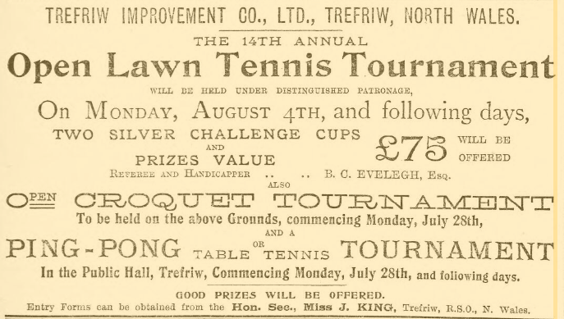
July 1902

Trefriw. Concert. - An enjoyable social function for the many visitors in this village was given in the Public Hall, Trefriw, on Thursday evening last.
August 1902

Trefriw. GRAND CONCERT.— With the praiseworthy object of raising funds to complete the purchase money of a pianoforte for the use of the parish, a concert was held in the Public Hall, Trefriw, on Friday evening last. ..... Mrs J. B. Cutter then performed a sweet and intricate solo upon the instrument, showing its rich and mellow tone.
November 1902

IMPROVEMENT OF THE VILLAGE. — In response to a generally-expressed opinion that the village and its attractions should be made more widely known, a meeting, of the lodging-house keepers will be held on Tuesday next at the Public Hall, when all interested are invited to attend.
January 1903

TREFRIW. The annual eisteddfod in connection with the Peniel Calvinistic Methodist Chapel was held on Christmas Day in the Public Hall, and was a great success.
January 1903

THE annual literary and musical competitive meeting, which is held under the auspices of St. Mary's Church, took place on New Year's Day at the Public Hall, and was very largely attended.
January 1903

Anti-Vivisection Meeting at Trefriw. "Cruelty is a Sin." On Thursday evening last week, a meeting was held at Trefriw Public Hall, under the auspices of the British Union for the Abolition of Vivisection.
March 1903

TREFRIW. Competitive Meeting. A competitive meeting in connection with the Ebenezer Congregational Chapel Band of Hope was held in the Public Hall, on Good Friday, and was a great success.
April 1903

Trefriw. THE "BIRDS' CANTATA."—The children of the Peniel Chapel (C.M.) Band of Hope gave a rendering of "Cantata yr Adar" on Saturday evening, in the Public Hall.
May 1903

PUBLIC IMPROVEMENTS.—A postponed public meeting of the villagers to consider various schemes: of improvement was held in the Public Hall on Tuesday night, when there was a good attendance.
July 1903

TREFRIW. AN ADVERTISING SCHEME.—On Thursday evening, at the Public Hall, the Rev John Gower presided over a variety entertainment held with a view of raising funds for the purpose of advertising the district.
July 1903

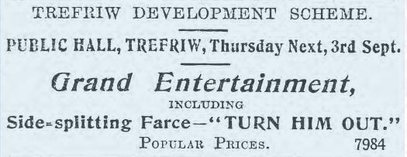
August 1903

"THE NEW WOMAN."—This was the title of a highly-diverting lecture given at the Public Hall, Trefriw, on Thursday evening, by Mr W. O. Jones, Aber.
August 1903

TREFRIW DEVELOPMENT SCHEME.— A capital concert has been arranged to take place on Thursday next, at the Public Hall, in aid of the funds of the above scheme. Contributions both humorous and serious have been arranged.
October 1903

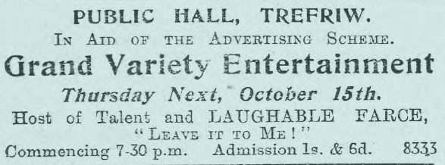
October 1903

TREFRIW. "VOICES OF NATURE.” The children of the Rhiwddolion Schools gave a performance of this operetta at the Public Hall, under the conductorship of Gutyn Arfon. The attendance was good, and the proceeds were in aid of the education of the children.
November 1903

Trefriw. THE IMPROVEMENT ASSOCIATION—A meeting of the Trefriw Improvement Association was held at the Public Hall on Saturday evening last.
March 1906

A meeting was held on Friday evening in the Public Hall, the Rev Henry Jones presiding. The question before the meeting was "The desirability of a library in the Public Hall."
April 1906

A soiree was held at the Public Hall to celebrate the opening of the Reading Room.
August 1906

ENTERTAINMENT.—With a view to swelling the funds of the reading room and library, an entertainment was held on Thursday evening, at the Public Hall, when there was a large audience.
February 1907

TREFRIW. ST. DAVID'S DAY.—The young people of the village are busy preparing for a performance of the trial of "Dic Shon Dafydd," which will take place at the Public Hall on St. David's Day.
February 1907

EVIDENCE AT THE INQUEST. At the Public Hall, Trefriw, on Friday, Mr J. Pentir Williams, Coroner for South Carnarvonshire, held an inquest on the body of Mr William Bradburn, 45 years of age, of Upper Brighton, Cheshire, who had been in the employ of Captain Vaughan, Drws-y-Coed, as gardener.
March 1907

TREFRIW CONCERT.—On Friday evening a concert was held at the Public Hall, the proceeds of which were in aid of Mr. Francis, the blind harpist.
October 1907

TREFRIW. COMING EVENTS.—This (Thursday) evening, the Public Hall platform will be occupied by local talent in aid of the Church Renovation Fund, and there will be produced the laughable farce entitled "The quiet family."
October 1907

SLUM LIFE IN LONDON. This night week the Rev. Henry Jones, Congregational Minister, delivered a lecture at the Public Hall on “The poor of a great city." The lecture dealt mainly with slum life in London and other large towns. The lecture was illustrated by lantern slides.
November 1907

Trefriw. ENTERTAINMENT. An entertainment was held at the Public Hall, on Thursday evening, in aid of the parish organ fund. One portion of the programme was devoted to a lantern lecture, entitled "A Dash for the North Pole."
October 1908

THE LIBRARY.—A meeting of the villagers will be held tonight at the Public Hall to consider the advisability of re-forming the Library or discontinuing it.
October 1908

TREFRIW, DRAMATIC ENTERTAINMENT.—A dramatic and miscellaneous entertainment took place at the Public Hall on Thursday, the proceeds of which were in aid of Mr. J. B. Knights' benefit as stage manager of the Llanrwst and Trefriw Dramatic Society, when the farce “Paddy and the Ghost” was produced, following which a programme of a miscellaneous nature was gone through.
January 1909

St. David's Day was celebrated at Trefriw by a dinner in the Rhianva Room, which was well patronised and much enjoyed. After the dinner the company adjourned to the Public Hall, where an impromptu concert was given. [Rhianva, a guest house, was demolished when the present woollen mill was built.]
March 1909

TREFRIW. ENTERTAINMENT.—An entertainment in aid of the new Chapel was given on Thursday evening in the Public Hall by the well-known Welsh ventriloquist and entertainer, “Ap Harri." There was a full house.
July 1909

ENTERTAINMENT. An entertainment was given at the Public Hall, on Thursday evening, in aid of the Public Reading Room.
August 1909

The ceremony of stone laying of the new Methodist Chapel has been postponed to September the 16th .... The ceremony is to be followed by a sale of work, which will be held at the Public Hall on that date and the two succeeding days.
September 1909

THE PUBLIC HALL. The interior of the Public Hall has undergone excellent treatment at the hands of the painters, which has completely changed in appearance; the present colouring, although dark, will no doubt prove more serviceable than the previous one. A chimney has also been added, doing away with the smoke nuisance which made the reading room at times so uncomfortable. With these changed conditions, those frequenting the Library will find the building altogether more comfortable.
September 1909

YOUNG HELPERS' LEAGUE.—Under the auspices of the League a tea and entertainment were held at the Public Hall on Saturday.
October 1909

RED RIDING HOOD.—On Thursday evening an excellent representation of “Red Riding Hood" was given at the Public Hall by the Mignon Dramatic Company. The proceeds were in aid of the electric light installation at Ebenezer Chapel.
October 1909

A whist drive was held on Thursday evening at the Public Hall.
June 1910

Trefriw Fancy Fair. A fancy fair in aid of improvements to St. Mary’s Church, Trefriw, was held on the beautiful lawn of Golden Grove, on Tuesday, through the kind permission of Mr. Campling, and at the Public Hall on Wednesday (yesterday).
August 1910

TREFRIW. The annual meeting of the local branch of the Welsh Farmers' Union was held at the Public Hall on Thursday.
May 1919

Electric lighting came to the village in 1905 –

LIGHTING OF THE PUBLIC HALL.— The work of lighting the public hall by electricity has now been completed, and presents a neat appearance and a decided improvement upon the old method of oil lamps. There will now be 33 lights of 16-candle power each. An arc lamp has also been placed at the entrance gate.
December 1905

In the second half of the 20th century a kitchen extension was added to the rear of the building, and toilets within a front extension. Neither of these additions were sympathetic to the original architecture.
Since 1996 it has carried Cadw Grade II listing.

References :
‘Hanes Eglwysi Annibynnol Cymru’ [The History of the Independent Churches of Wales] by Thomas Rees & John Thomas, 1871
‘Hanes Trefriw’ [The History of Trefriw] by Morris Jones, 1879
‘Ebenezer Trefriw, Hanes yr Achos Annibynnol yn Nhefriw’ [The History of the Independent Cause in Trefriw] by W.G. Roberts, 1939

